Wastage Aware Routing

Table of Contents

Routing Metrics 3

Examples 4

One of the most challenging issues we saw with **wireless sensor networks** was the **limited battery-life** of the devices. To deal with this, **energy-harvesting wireless sensor networks** were created, which were capable of harvesting energy from their environment. This meant that, if handled properly, the devices could potentially have an infinite lifetime.

Even though energy harvesting WSNs are great, we need to keep several factors in mind. Things like the short-term depletion of battery (how will we get solar power at night?), or the random nature of energy harvested (not every day is equally sunny).

Keeping this in mind, the routing strategy we choose must try to maximize the **total remaining energy** in the network and also maximize the **minimum energy level** in the network, i.e. a single node having very low energy in a route which has low overall energy usage might invalidate the route in order to keep that single node alive.

## Routing Metrics

Various routing metrics have been considered for energy harvesting WSNs:

* Battery residual energy
* Predicted harvest energy
* Estimated energy consumption
* Channel condition

However, before [this](https://ieeexplore.ieee.org/document/6804635) paper, no one took into consideration the wastage of energy due to **overcharge**. For example, if a device is at 90% battery capacity and we do not use it for a time period in which it could potentially have gained back 20% of its battery capacity, then we are wasting 10% of the battery capacity (i.e. it gets filled to 100% and then another 10% of potential battery life is not harvested).

An optimal solution can therefore involve **maximizing the utilization of harvested energy**. For the above example, in the time it takes the device to gain back 20% of its battery life, if we use 10% of its battery to make transmissions, there will be no wastage. Formally, we are minimizing the sum of the energy consumption due to transmission and the energy wastage due to overcharge.

## Examples

Consider that we have the situation below, where there are two routes between the sender and the receiver, and we are using the top route.



The wastage from nodes 1 and 2 is called the **on-path wastage**. The wastage from nodes 3, 4 and 5 is called the **off-path wastage**. The total energy wasted due to using the top route is the total on-path and off-path wastage, summed with the transmission energy use.

In the diagram below, refers to the energy in the th node, is the energy harvested in the th node, is the energy used for transmission, is the energy wasted if the node is not used and is the energy wasted if the node is used.

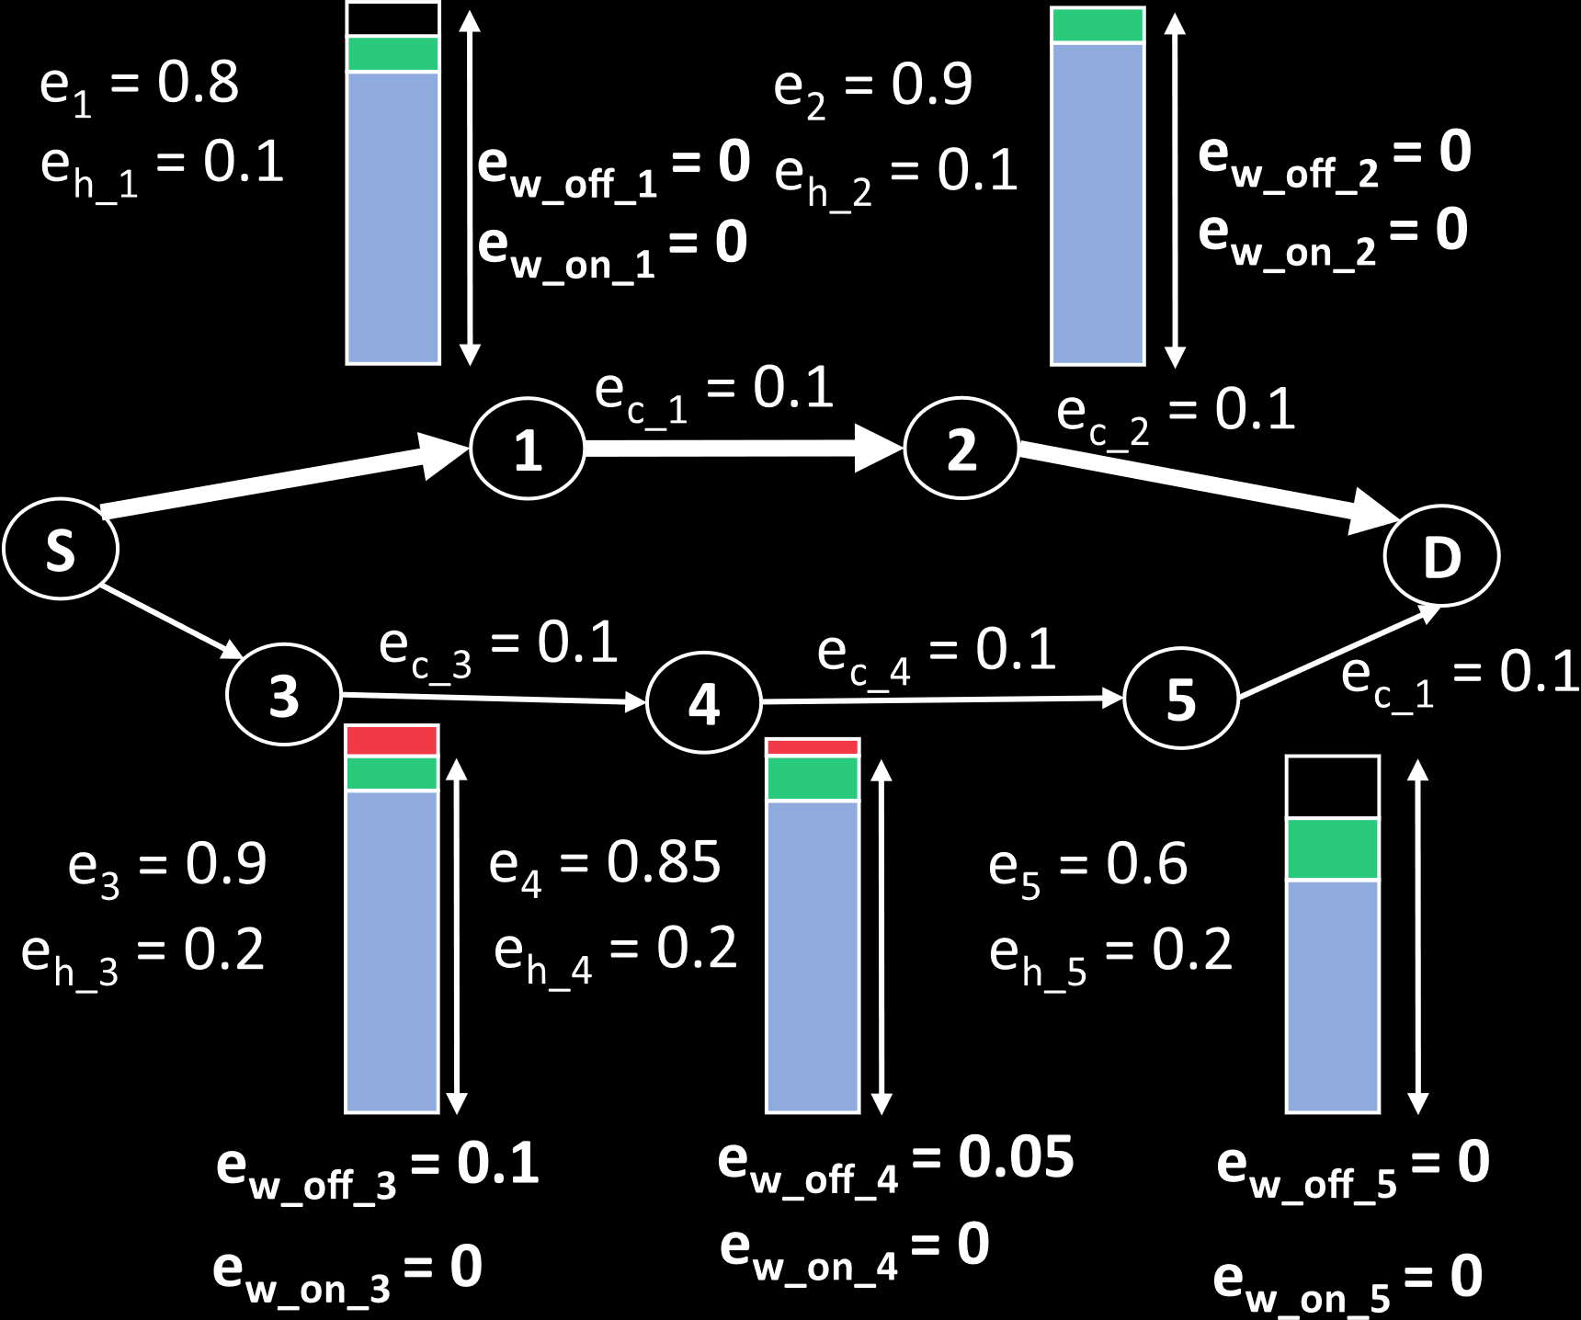

Consider the first node. It has 80% battery and can harvest another 10% in the time it takes to transmit the packet. If we do not use the node, there is 0 wastage. If we do use the node, then the transmission takes 10% battery, but this still results in 0 wastage.

Similarly, we can find the wastage due to using and not using each of the nodes. From this, the total cost of using the top route is , with the first two values being the transmission costs of node 1 and 2 respectively.

If instead we had used the bottom route, the total cost would have been . Thus, we should use the bottom route, since it gives us the minimum cost and maximum remaining energy.